*A Project report on*

**AN OVERVIEW ON CHUBB CORPORATION AS A SOFTWARE ENGINEER INTERN**

**C:\Users\AKSRIVA\AppData\Local\Microsoft\Windows\INetCache\Content.MSO\8D978F3.tmp**

*Submitted in partial fulfilment for the award of the degree in*

**Bachelor of Technology**

*by*

**AKASH SRIVASTAVA (17BEE1037)**



**SELECT**

June,2021

**DECLARATION**

I here by declare that the thesis entitled “An Overview on Chubb Corporation as a Software Engineer Intern” submitted by me, for the award of degree in Bachelor of Technology .VIT and Placement Cell is a record of bonafide work carried out by me under the supervision of following during my Internship at Chubb under Digital and Analytics Tower:

1. Kapil Agrawal (Manager/Tower Lead)
2. Srikanth Boddula (Mentor/ Software Engineer)
3. Angleswar Chadrasekar (Mentor/Software Engineer)
4. Uday Kumar Mydem (Mentor/Sr Software Engineer)

I further declare that the work reported in this thesis has not been submitted and will not be submitted and will not be submitted, either in part or in full, for the award of any other degree or diploma in this institute or any other institute or university.

Place: Lucknow

Date: 21st June 2021

Signature of the Candidate:

**Internship Completion Certification**

**ABSTRACT**

**ACKNOWLEDGEMENT**

**CONTENT**

|  |  |  |
| --- | --- | --- |
| S.no | Chapter | Page |
| 0. | |  |  | | --- | --- | | I. | Declaration | | II. | Certification | | III. | Abstract | | IV. | Acknowledgement | | |  | | --- | |  | |  | |  | |  | |
| 1. | Chapter 1: Introduction |  |
| 2. | Chapter 2: About the Company   |  |  | | --- | --- | | I. | About Chubb Corporation | | II. | About Chubb India | | III. | Workflow and Infrastructure | | IV. | Digital and Analytics | | |  | | --- | |  | |  | |  | |  | |
| 3. | Chapter 3: Training Phase   |  |  | | --- | --- | | I. | Training Workflow | | II. | Database Training | | III. | Frontend Training | | IV. | Backend Training | | |  | | --- | |  | |  | |  | |  | |
| 4. | Chapter 4: Minor Projects   |  |  | | --- | --- | | I. | Authentic Dashboard-YouTube Clone | | |  | | --- | |  | |
| 5. | Chapter 5: Conclusion |  |

**CHAPTER 1**

**Introduction**

**CHAPTER 2**

**About the company**

1. **About Chubb Corporation**

Chubb is the world’s largest publicly traded P&C insurance company and a leading commercial lines insurer in the U.S. With operations in 54 countries and territories, Chubb provides commercial and personal property and casualty insurance, personal accident and supplemental health insurance, reinsurance and life insurance to a diverse group of clients. As an underwriting company, we assess, assume and manage risk with insight and discipline. We service and pay our claims fairly and promptly. We combine the precision of craftsmanship with decades of experience to conceive, craft and deliver the very best insurance coverage and service to individuals and families, and businesses of all sizes.

Chubb is also defined by its extensive product and service offerings, broad distribution capabilities, direct-to-consumer platform partnerships, exceptional financial strength and local operations globally. The company serves multinational corporations, mid-size and small businesses with property and casualty insurance and risk engineering services; affluent and high net worth individuals with substantial assets to protect; individuals purchasing life, personal accident, supplemental health, homeowners, automobile and specialty personal insurance coverage; companies and affinity groups providing or offering accident and health insurance programs and life insurance to their employees or members; and insurers managing exposures with reinsurance coverage.

Chubb has more than $190 billion in assets and reported $41 billion of gross premiums written in 2020. Chubb’s core operating insurance companies maintain financial strength ratings of AA from Standard & Poor’s and A++ from A.M. Best.

Chubb Limited, the parent company of Chubb, is listed on the New York Stock Exchange (NYSE: CB) and is a component of the S&P 500 index.

Chubb maintains executive offices in Zurich, New York, London, Paris and other locations, and employs approximately 31,000 people worldwide.

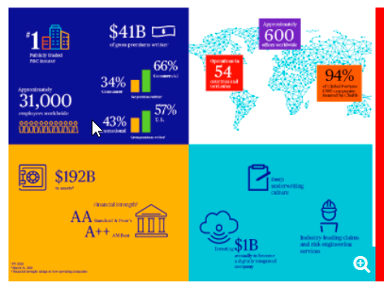

Figure 1: Chubb At A Glance

1. **About Chubb India**
2. **Workflow and Infrastructure**
3. **Digital and Analytics**

**CHAPTER 3**

**Training Phase**

1. **Training Workflow**

In first month of Internship I was undergone through regressive training for the full stack role. My technology stacks in the training was MEAN stack. The workflow of training includes

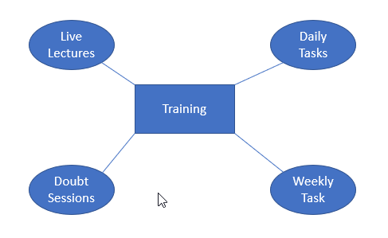

Daily the trainer gives me the live lectures on required topics which was necessary for me to be as a full stack developer. The lecture was given in morning hours from 10 AM and it ends daily at 2 PM. After lunch hour always had a doubt session if needed to do the daily given task.

I was trained as a full stack developer in the following technology stacks:

1. SQL DB
2. MongoDB
3. JavaScript
4. TypeScript
5. HTML
6. CSS/SCSS
7. Angular
8. Node.js
9. Express.js
10. Rest APIs

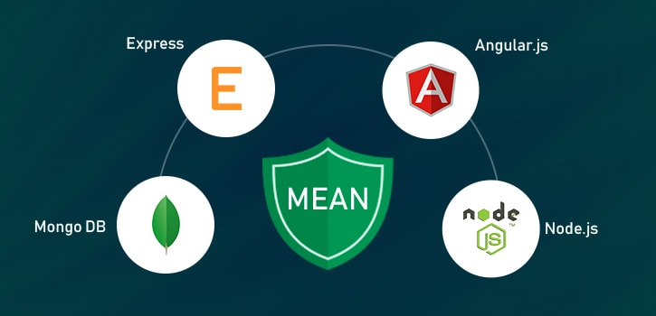

1. **Database Training**

During my first phase of training I was undergone training in MySQL and MongoDB database. The Syllabus was structuring the database, querying the database according to problems and requirements are given.

* **Task**

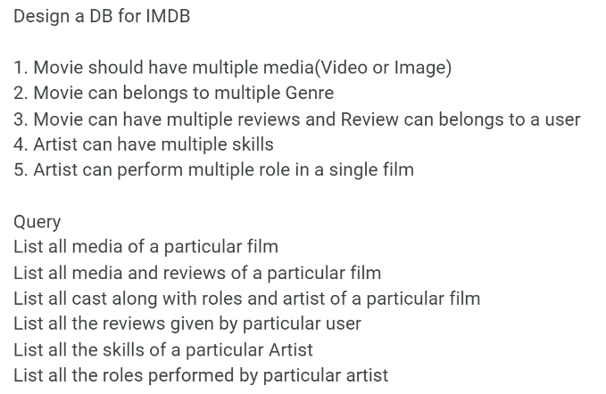

* **Flowchart**

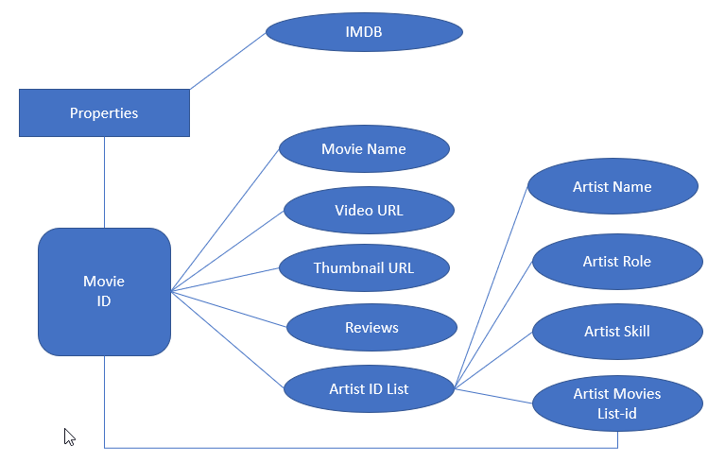

* **Database Design as Table**

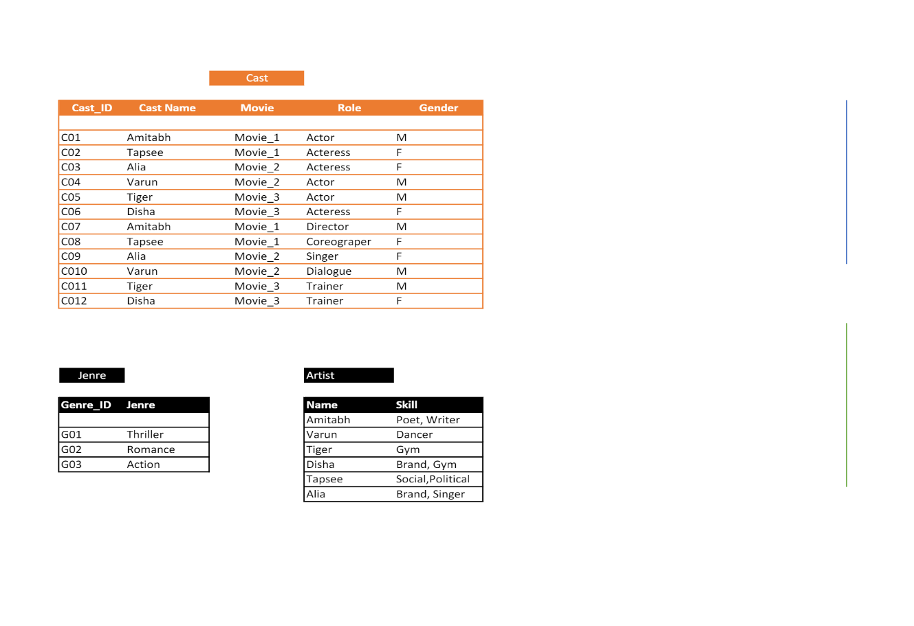

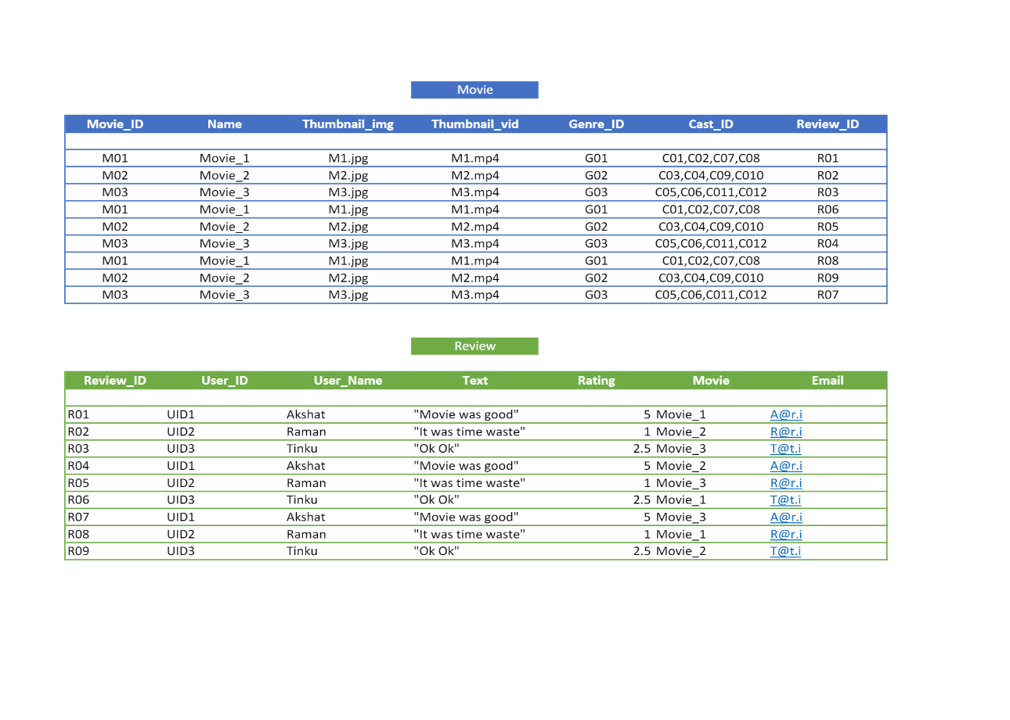

* **Database Design as Json**
* **Querying on SQL**
* **Querying on MongoDB**

1. **Frontend Training**
2. **Backend Training**

**CHAPTER 4**

**Minor Project**

* **4.1 Problem Statement**

**Que:**

* **4.2 Solution Architecture**
* **4.3 Database Design**
* **4.4 Project Coding**
* **4.5 Project Output**